To check the license status of your FortiGate firewall
To check the license status of your FortiGate firewall, you can follow these methods:
1. Using the FortiGate GUI
- Log in to the FortiGate GUI.
- Go to Dashboard > Status.
- Look for the License Information or FortiCare Support widget. This section provides details about your FortiGate license, including the expiry date of your support contract and feature licenses (like IPS, AV, Web Filtering).
- If you don’t see it, you can add it to the dashboard by selecting + and adding License Information.
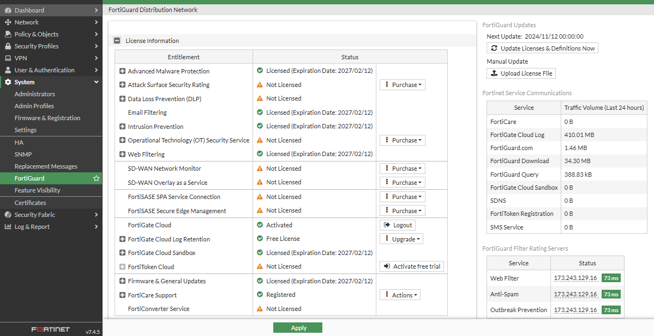
2. Using the FortiGate CLI
- Log in to your FortiGate through SSH or the console.
- Use the following command to check license details:
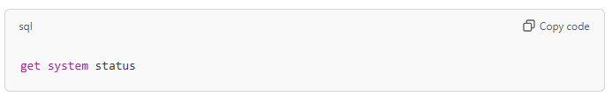
- This command provides information on your firmware version, license, and serial number.
- You can also check license details specifically with:
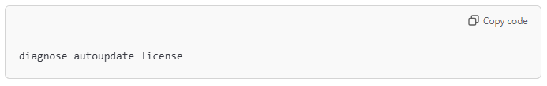
This command displays license information and its validity, including details on FortiGuard services.
3. Using FortiCloud/FortiCare Portal
- Go to the FortiCloud portal and log in with your Fortinet account.
- Select your device from the registered products list to see information on license and support contract status.
4. Through FortiManager (If Managed)
- If your FortiGate device is managed by FortiManager, you can check the license status within FortiManager.
- Go to Device Manager, select the device, and find license details under System Information.
By keeping your FortiGate license active, you ensure continued access to essential services like security updates and technical support.

